SMART HEALTH
Submitted in partial fulfilment of the requirements of the degree of
BACHELOR OF COMPUTER ENGINEERING
by
Anand Singh, 22102098
Jayhind Vishwakarma, 22102163
Rajit Yadav, 22102077
Furqan Ali Syed, 21102098

Guide:

Prof. Vandana R. Virbhadre


Department of Computer Engineering
A.P. SHAH INSTITUTE OF TECHNOLOGY, THANE
(2024-2025)

A.P. SHAH INSTITUTE OF TECHNOLOGY, THANE


CERTIFICATE
This is to certify that the project entitled “SMART HEALTH” is a bonafide work of Anand Singh (22102098), Jayhind Vishwakarma (22102163), Rajit Yadav (22102077), Furqan Ali Syed (21102098) submitted to the University of Mumbai in partial fulfilment of the requirement for the award of the degree of Bachelor of Engineering in Computer Engineering.

_____________ ______________
Prof. Vandana R. Virbhadre Prof. Rushikesh R.Nikam
Guide Project Coordinator

_____________ _______________
Dr. Sachin H. Malave Dr. Uttam D. Kolekar
Head of Department Principal

A. P. SHAH INSTITUTE OF TECHNOLOGY, THANE

Project Report Approval for B.E.
This project report entitled “SMART HEALTH” by Anand Singh, Jayhind Vishwakarma, Rajit Yadav, Furqan Ali Syed is approved for the degree of Bachelor of Engineering in Computer Engineering, 2024-25.

Examiner Name Signature
1.________________ _____________
2._________________ ______________

Date:
Place:

Declaration
We declare that this written submission represents my ideas in my own words and where others' ideas or words have been included, we have adequately cited and referenced the original sources. We also declare that we have adhered to all principles of academic honesty and integrity and have not misrepresented or fabricated or falsified any idea/data/fact/source in my submission. We understand that any violation of the above will be cause for disciplinary action by the Institute and can also evoke penal action from the sources which have thus not been properly cited or from whom proper permission has not been taken when needed.

-----------------------------------------
Anand Singh - 22102098

-----------------------------------------
Jayhind Vishwakarma - 22102163

-----------------------------------------
Rajit Yadav - 22102077

-----------------------------------------
Furqan Ali Syed 21102098

Date:

Abstract

In recent years, mental health challenges such as stress, anxiety, and burnout have become increasingly prevalent, necessitating innovative therapeutic solutions. Traditional methods like therapy and mindfulness exercises have been effective, but technological advancements now offer new ways to address these issues. This project introduces "Mental Relaxation using Virtual Reality", a Virtual Reality (VR)-based application designed to promote relaxation and improve mental well-being by immersing users in calming, interactive environments. By leveraging the immersive potential of VR, "Mental Relaxation using Virtual Reality" transports users into serene virtual locations, such as beaches, forests, and mountains, creating an effective escape from daily stressors.

In addition to its immersive environments, the application incorporates therapeutic exercises such as guided meditations, breathing techniques, and mindfulness-based activities. The project aims to provide an accessible, personalized mental health solution that helps users manage stress, improve emotional resilience, and foster overall mental well-being. This exploration of VR in mental health care demonstrates the potential for technology to revolutionize relaxation techniques and offer a unique, immersive approach to mental wellness.

CONTENTS
  - Introduction..........................………………………..……………..……………….…. 1
  - Literature Survey………………...……………..…………………..……………….….3
  - Limitation of Existing System………………………………………….………………9
  - Problem Statement, Objectives and Scope………….......…….……….….…………...11
5. Proposed System…………..……...……..……………….……………….……………13
6. Experimental Setup……..…….………...……..……………………….………………21
7. Project Plan ……………………………….………………………………………...…24
8. Expected Outcome ........................................................................................................25
References……...............................................................................................................27

LIST OF FIGURES
5.2 Architecture diagram........................................................................................................14
5.3.1 Data Flow Diagram - Level 0.…......................................................................................15
5.3.2 Data Flow Diagram - Level 1….......................................................................................16
5.3.3 Data Flow Diagram - Level 2….......................................................................................16
5.4 Sequence Diagram ............................................................................................................17
5.5 Activity Diagram …..........................................................................................................18
5.6.1 Underwater Game Environment.....................................................................................19
5.6.2 Underwater Game Environment.....................................................................................19
5.7.1 Forest Environment…………........................................................................................20
5.7.2 Forest Environment…………........................................................................................20

LIST OF TABLES
2. Literature Survey .................................................................................................................4

LIST OF GRAPHS
7.1 Gantt Chart.............................................................................................................,...........25

ABBREVIATION
VR Virtual Reality  STAI State-Trait Anxiety Inventory  EDA Electrodermal Activity  PTSD Post-Traumatic Stress Disorder  CBT Cognitive-Behavioral Therapy  VAS Visual Analogue Scales  HMDs Head-Mounted Displays  CAVE Cave Automatic Virtual Environment  AI Artificial Intelligence  UML Unified Modeling Language  DFD Data Flow Diagram | `

Chapter 1
Introduction

In today's fast-paced, stress-driven world, mental health has become a critical concern, with increasing numbers of individuals experiencing anxiety, stress, and burnout. While traditional methods like therapy and mindfulness have proven effective, the integration of technology offers new and innovative ways to address mental health challenges. One such innovation is Mental Relaxation using Virtual Reality, a virtual reality-based application designed to promote relaxation and mental well-being. By leveraging the immersive power of Virtual Reality (VR), this project transports users into calming environments and engages them in interactive experiences that help alleviate stress and improve overall mental health.

Mental Relaxation using Virtual Reality aims to revolutionize the way individuals approach mental wellness by offering a range of immersive environments—such as serene beaches, tranquil forests, peaceful mountain landscapes, and even calming rain showers—where users can escape the pressures of daily life. This technology creates a deep sense of presence, making the experience feel as though users are truly in these peaceful locations. In addition to these environments, the system includes therapeutic games and exercises designed to promote relaxation, mindfulness, and stress relief. Whether users are looking to unwind after a long day or build lasting coping mechanisms, Mental Relaxation using Virtual Reality provides a personalized, immersive experience to support mental health.

Key features of the project include:

- A variety of virtual environments that simulate real-world locations known to reduce stress and promote relaxation.

- Interactive mental health exercises, including breathing techniques, guided meditations, yoga practices, and cognitive-based mini-games.

- Customizable experiences tailored to individual preferences, allowing users to select the environment and activities that best suit their mental health needs.

Moreover, Mental Relaxation using Virtual Reality integrates educational resources on mental health, empowering users with knowledge about anxiety management, coping strategies, and self-care practices. By fostering a sense of community and shared experience, Mental Relaxation using Virtual Reality enhances the overall therapeutic experience. With the potential for collaboration with mental health professionals, the application can also serve as a supplementary tool in traditional therapy settings, providing an engaging way for individuals to continue their healing process between sessions.

As mental health becomes an increasingly urgent topic in our society, Mental Relaxation using Virtual Reality positions itself not just as a product, but as part of a broader movement towards accessible and innovative mental health care solutions. By harnessing the power of technology, Mental Relaxation using Virtual Reality offers a fresh perspective on mental wellness, making self-care an immersive, enjoyable, and transformative experience.

Chapter 2
Literature Survey
Relaxation techniques, particularly Progressive Muscle Relaxation and deep breathing, are effective in reducing anxiety and distress among adolescents. While VR is not mentioned directly in this study, the effectiveness of these techniques in face-to-face sessions opens up possibilities for their VR adaptation [1].
VR-based guided imagery has been shown to significantly reduce workplace stress among healthcare professionals. The VR experience uses immersive, nature-based environments combined with soothing sounds, replicating traditional guided imagery with the added benefit of deeper immersion [2]. Deep breathing exercises, enhanced through VR using real-time biofeedback and immersive environments, showed promise in improving both psychological and physiological states of relaxation. The use of VR to provide synchronized auditory and visual cues aligned with user breathing enhances user engagement [3]. VR environments demonstrated greater efficacy in reducing state anxiety and enhancing relaxation compared to traditional DVD or audio-based methods. This was measured using self-report metrics like the State-Trait Anxiety Inventory (STAI) [4]. Most VR stress-reduction systems utilize commercial VR headsets like Oculus, often combined with sensors to track physiological signals such as heart rate and electrodermal activity (EDA). These systems have been evaluated using both subjective and objective metrics [5]. VR has been increasingly used in clinical settings to treat psychiatric conditions such as PTSD, anxiety disorders, and phobias. It facilitates cognitive-behavioral therapy (CBT) by allowing patients to revisit traumatic experiences in a controlled, immersive environment [6].
High-fidelity VR simulations provide a strong sense of presence, allowing users to practice emotion regulation in immersive, real-time environments. The use of game engines like Unity3D and Unreal Engine makes the simulations highly realistic and engaging [7]. Integration of VR with data collection technologies such as eye-tracking and physiological sensors enables real-time monitoring of behaviors and responses. This approach provides more precise assessments of mental health symptoms and can help in tailoring interventions [8]. Neurofeedback combined with VR offers an immersive environment where users can train to optimize brain activity for emotional self-regulation. This combination enhances the effectiveness of neurofeedback training by making the experience more engaging [9].

SR.  NO | PAPER TITLE | AUTHOR AND  PUBLICATION | FINDINGS
1 | “Effectiveness of relaxation techniques to reduce distress, anxiety and depression in adolescents” | Hamdani SU,  Zill-E-Huma, Zafar SW,  Suleman N,  Um-Ul-Baneen, Waqas A,  Rahman A  Human Development  Research Foundation  (HDRF), Pakistan|  Institute of Population  Health, Department of  Primary Care and Mental  Health,  University of Liverpool,  UK|  (September 30, 2020) | - Relaxation techniques are effective in reducing anxiety (-0.54 effect size) and distress (-0.48 effect size) in  adolescents, with a weaker effect on  depression (-0.28 effect size).  - Somatic techniques (e.g., Progressive  Muscle Relaxation, deep breathing) are  the most effective.  - Face-to-face delivery is more effective than online methods.  - Adolescents find these techniques  easy to learn and use, though consistent practice can be challenging.
2 | “Guided imagery: Harnessing the  power of imagination to combat workplace stress for health care  professionals” | Rita Cola Carroll  Drexel University, USA,  Journal of  Interprofessional  Education & Practice  Volume 28, September  2022, 100518 | - This VR application would use immersive, 360-degree environments to create relaxing and pleasant  multi-sensory experiences.  -The VR simulation could include  nature-based visuals and soothing  sounds.
3 | “Effectiveness of Progressive Muscle Relaxation, Deep  Breathing, and Guided Imagery in Promoting  Psychological and Physiological States  of Relaxation” | Toussaint L, Nguyen QA,  Roettger C, Dixon K,  Offenbächer M, Kohls N,  Hirsch J, Sirois F.  Evid Based Complement  Alternat Med. 2021; 2021:  5924040. | - Deep breathing exercises can be  enhanced in VR by using real-time  biofeedback and immersive  environments.  -VR can enhance user experience by tailoring environments and exercises to individual preferences  -VR can provide visual or auditory cues that synchronize with the user's breath, and real-time monitoring of  physiological responses.
4 | “New Technologies for Relaxation: The Role of Presence” | Daniela Villani, Francesco  Riva, Giuseppe Riva  Article in International  Journal of Stress  Management | August  2007 | -The VR condition demonstrated superior efficacy in reducing state anxiety and enhancing relaxation compared to the DVD and audiotape conditions.  -This was quantified using self-report measures, including the STAI and Visual  Analogue Scales (VAS), with VR showing statistically significant improvements in these metrics.
5  6 | “Virtual reality environments for stress reduction and management: a scoping review”  “Virtual Reality and  Mental Health Care" | Ioannis Ladakis, Filos D,  Chouvarda Ioanna  https://doi.org/10.1007/s1  0055-024-00943-y |  27 February 2024  Rishikeshava Damarla  Volume 11 Issue 4 (2022) | -Most VR stress reduction systems utilize commercial VR headsets like Oculus and Vive, often combined with additional sensors to capture physiological signals. Unity and Unreal Engine are popular software tools used for developing these environments.  - The systems are typically evaluated through both subjective (questionnaires) and objective (physiological signals like HR, HRV,  EDA) measurements.  -The paper highlights the use of clinical VR for treating psychiatric conditions such as PTSD, anxiety disorders, phobias, and eating disorders. VR facilitates Cognitive Behavioral Therapy (CBT) by immersing patients in scenarios that allow them to revisit and reassess traumatic or anxiety-inducing experiences.
7 | “Virtual Reality and Stress Management: A Systematic Review.” | Shakila Meshkat , Mahsa  Edalatkhah , Corinna Di  Luciano , Josh Martin ,  Gursharanjit Kaur , Gyu  Hee Lee , Haley Park ,  Andrei Torres , Ali  Mazalek , Bill Kapralos ,  Adam Dubrowski , Venkat  Bhat  Cureus. 2024 Jul; 16(7):  e64573. | - A therapeutic approach where individuals are gradually exposed to stressors or phobias within a controlled VR setting to reduce anxiety and stress levels.  - Combining VR with other therapeutic techniques such as cognitive behavioral therapy CBT to enhance effectiveness in treating mental health conditions.
8 | “Virtual Reality for the Enhancement of Emotion Regulation” | Colombo Desirèe,  Díaz-García Amanda,  Fernández-Álvarez Javier,  Botella Cristina  Article in Clinical  Psychology &  Psychotherapy · May 2021 | -VR leverages high-fidelity, immersive simulations that create a strong sense of presence (the feeling of "being  there") within virtual environments. These environments are designed using real-time 3D rendering technologies, often powered by game engines like Unity3D or Unreal Engine, to provide realistic scenarios that facilitate emotion regulation training.
9 | “Virtual reality as a clinical tool in mental health research and practice” | Bell IH, Nicholas J, Alvarez-Jimenez M,  Thompson A, Valmaggia L.  Dialogues Clin Neurosci.  2020 Jun; 22(2): 169–177. | -Integration of VR with data collection technologies (e.g., eye-tracking, physiological sensors) allows for real-time, automated monitoring of behaviors and physiological responses. This capability enhances the precision of assessments and can reveal insights into symptom dynamics.
10 | “Emotional self-regulation, virtual reality and neurofeedback” | Joana Pinheiro, Raquel  Simões de Almeida,  António Marques  Center for Rehabilitation  Research - Psychosocial  Rehabilitation Lab, School  of Health of P.PORTO,  Porto, Portugal (2021) | -Neurofeedback, based on brain-computer interaction, allows individuals to train and optimize their brain activity, which, when combined with VR, creates immersive environments that can enhance the effectiveness of this training.  - The paper discusses the development and application of serious games that utilize neurofeedback in VR settings.
11 | “Virtual reality in the assessment, understanding, and treatment of mental health disorders.” | Freeman D, Reeve S,  Robinson A, Ehlers A,  Clark D, Spanlang B,  Slater M.  Psychol Med. 2017 Oct;  47(14): 2393–2400. | -VR creates immersive, interactive computer-generated environments that replace real-world sensory perceptions. These environments are designed to induce a sense of presence (PI) and plausibility (Psi) in users.  - Includes Head-Mounted Displays (HMDs), CAVE (Cave Automatic Virtual Environment), and other  immersive setups that provide a high level of sensory
12 | “Virtual reality relaxation for mental health staff in complex care services: A feasibility and acceptability study” | Grace Williams , Mariam  Riaz , Eugenia Drini ,  Simon Riches  Mental Health &  Prevention Volume 33,  March 2024, 200318 | -VR creates highly immersive virtual environments that can transport users to calming, nature-based settings like beaches or underwater scenes.  -Post-VR, participants planned and carried out behavioral activities that extended the benefits of the VR session to real-world applications, indicating the potential for sustained impact beyond the immediate VR experience.
13 | “Virtual Reality Relaxation for Mental Health Service Users with Complex Care Needs: a Pilot Study in Residential Care Homes and Supported Accommodation” | Grace Williams, Eugenia  Drini, Simon Riches  Journal of Psychosocial  Rehabilitation and Mental  Health 2024-04-12 |  Journal article | -The study demonstrates that VR relaxation is a feasible intervention for mental health service users with complex care needs.  -It can be effectively delivered in residential care homes and supported accommodations using head-mounted  displays (HMDs) like the Oculus Go.
Chapter 3
Limitation of Existing system

- Short-Term Focus: Most studies on VR for mental relaxation often assess immediate effects rather than long-term benefits. This creates uncertainty about the sustainability of relaxation achieved through VR interventions over time.

- Limited Population Diversity: Research on VR-based mental relaxation frequently targets specific groups, such as young adults or healthcare professionals, which may not represent broader populations. There is a need for studies involving diverse demographics, including different age groups, cultural backgrounds, and individuals with varying mental health conditions.

- Accessibility and Cost Barriers: The high cost of VR headsets and software can be a barrier to access for many potential users. Existing studies often do not address how to make VR relaxation interventions available to underserved populations or those with limited resources.

- Technical Issues and Usability: Users may experience technical difficulties with VR equipment or interfaces, leading to frustration and reduced effectiveness of the relaxation experience. Issues such as motion sickness, discomfort, or difficulty navigating VR environments can deter users from engaging with the technology.

- Limited Research on Customization: While some VR applications allow for a degree of customization, there is limited research on how individual preferences and needs can be better incorporated into VR relaxation interventions. Tailoring VR experiences to suit different users could enhance their effectiveness.

- Potential Psychological Risks: VR immersion can sometimes lead to negative psychological effects, such as disorientation or overstimulation. The risk of triggering anxiety or distress in certain individuals during VR relaxation sessions is not well-studied, raising concerns about safety and appropriateness for all users.

- Integration with Traditional Therapies: Existing VR relaxation interventions are often evaluated as standalone solutions, with limited exploration of how they can be integrated with traditional mental health therapies or practices (e.g., mindfulness, CBT). This limits the potential for creating holistic treatment approaches.

- Insufficient Evidence of Efficacy Across Conditions: While VR has shown promise in certain contexts, there is insufficient evidence regarding its effectiveness for a wide range of mental health conditions, such as severe anxiety, depression, or PTSD. More research is needed to establish its efficacy in diverse clinical settings.

- Ethical and Privacy Concerns: The collection of personal data during VR sessions raises ethical concerns regarding user privacy and data security. The lack of clear guidelines on data management in VR applications can deter users from fully engaging with the technology.

Chapter 4
Problem Statement, Objectives and Scope

4.1 Problem Statement
Mental health disorders, including anxiety, depression and stress, have become increasingly prevalent, affecting millions of people worldwide. Despite the recognition of the importance of mental health, there are significant challenges in providing effective care and support to those in need.

4.2 Objectives
- Increase Accessibility to Mental Health Care:
Ensure that individuals experiencing mental health disorders have easy access to professional support and resources, particularly in underserved areas.
- Enhance Early Detection and Intervention:
Develop systems and tools for the early identification of symptoms to prevent the escalation of anxiety, depression, and stress into more severe conditions.
- Improve Personalized Care and Treatment:
Provide tailored interventions based on individual needs, ensuring that treatment plans are personalized and take into account the specific challenges faced by each person.
- Enhance the Integration of Technology in Mental Health:
Leverage emerging technologies, such as AI, virtual reality (VR), and mobile applications, to deliver mental health support in innovative ways.

4.3 Scope
- Personalized Calm Environments:
Users can enter personalized calm environments that offer soothing soundscapes, relaxing visuals, and mindfulness exercises. These environments will adapt to the user's mood and stress level, offering experiences designed to induce relaxation and calm.
- Stress-Relief Games for Mental Wellness:
The app will feature a variety of interactive games designed to reduce stress and anxiety. These games will be based on cognitive behavioural techniques that help users focus, relax, and shift attention away from negative thoughts.
- Guided Physical Exercises for Stress Reduction:
The app will feature guided exercise routines, such as yoga, deep breathing exercises and light cardio, aimed at reducing stress and promoting mental relaxation. These exercises will be tailored to user preferences and needs.

Chapter 5

Proposed System

Mental Relaxation using Virtual Reality is designed to enhance mental well-being through an immersive VR relaxation system. The platform aims to provide a calming and therapeutic experience for users, offering various virtual environments tailored to reduce stress and improve mental health. Through guided meditation, soothing visuals, and peaceful soundscapes, Mental Relaxation using Virtual Reality allows users to escape daily stressors and focus on mindfulness.

  - Modules:
- Homepage: Provides various options available such as calm VR, Exercise mode and VR Games. Users can pick any of the options and be stress free using the VR.

- User: can explore various virtual environments designed for relaxation and mental wellness. They can choose different modes, such as guided meditation or calming visuals, to reduce stress and improve focus.

- Admin: manage the platform by overseeing user activity, customizing available relaxation modes, and monitoring system performance to ensure an optimized and seamless experience for all users.

- VR Games: Interactive and soothing VR games are designed to engage users in relaxing activities, promoting mindfulness while subtly guiding them through stress-relieving exercises in an immersive environment.

- Exercise mode: This mode offers guided physical exercises within a virtual environment, promoting light physical activity combined with breathing techniques to help users de-stress and improve both mental and physical well-being.

- Calm VR: Calm VR provides users with tranquil, scenic virtual landscapes, such as serene beaches or peaceful forests, accompanied by calming sounds, helping users achieve mindfulness and inner peace.
5.2 Architecture Diagram:
An Architectural diagram is a visual representation that maps out the physical implementation of the components of the software system. The architecture diagram of Mental Relaxation using Virtual Reality consists of various options for user preferences and the input is given to the controller and sensors. Whereas, the output is displayed on the VR Headset. It consists of three different categories which are Calm VR, Exercise Mode and VR Games.

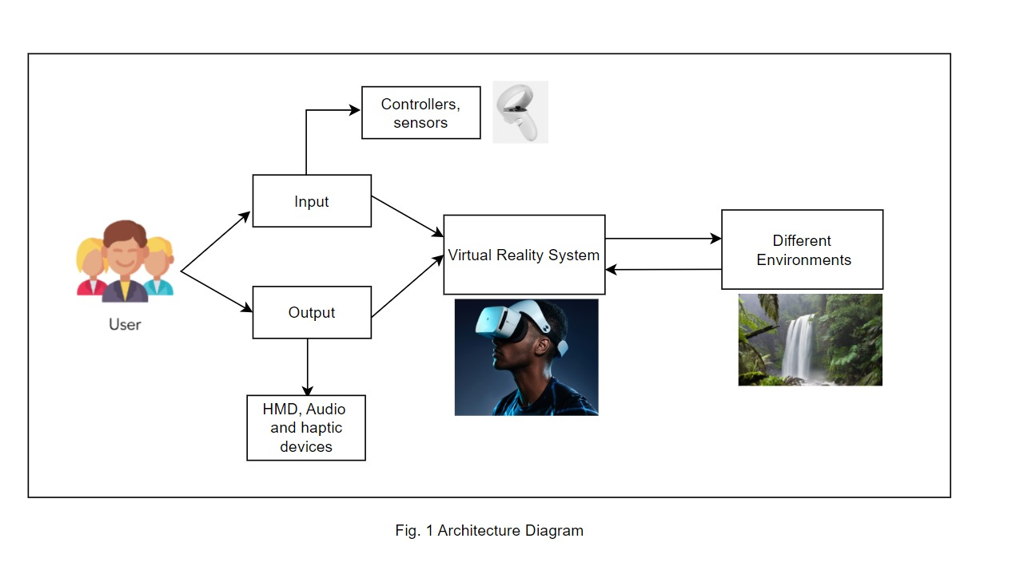
Figure 5.2 – Architecture Diagram

5.3 UML Diagrams:
A UML diagram is a diagram based on the UML (Unified Modelling Language) to visually represent a system along with its main actors, roles, actions, artifacts, or classes, to better understand, alter, maintain, or document information about the system.

5.3.1 DFD Diagram
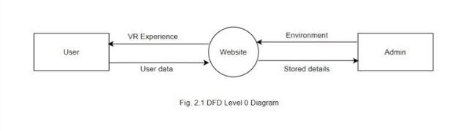
Figure 5.3.1 – DFD Level 0 Diagram
A data flow diagram (DFD) maps out the flow of information for any process or system. It uses defined symbols like rectangles, circles, and arrows, plus short text labels, to show data inputs, outputs, storage points, and the routes between each destination. At Data Flow Diagram (DFD) level 0 for Mental Relaxation using Virtual Reality based on VR technology, the diagram depicts the main external entities: User and Admin.

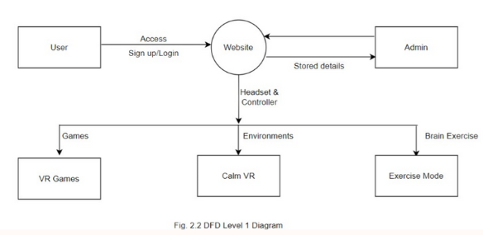
Figure 5.3.2 – DFD Level 1 Diagram
In DFD level 1 for Mental Relaxation using Virtual Reality based on VR technology, the primary process at level 0 is expanded into detailed subprocesses. For example, the website will have a variety of options for the users to choose from such as VR Games, Calm VR and Exercise mode.
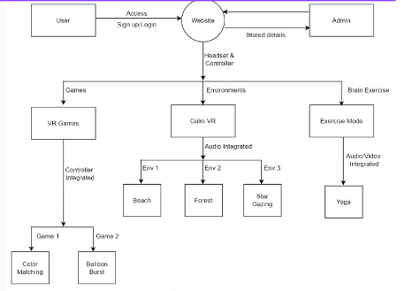
Figure 5.3.3 – DFD Level 2 Diagram

In a Data Flow Diagram (DFD) level 2 for Mental Relaxation using Virtual Reality based on VR technology, the subprocesses of "Login" and "Sign Up" are further detailed. "Login" involves verifying user credentials, while "Sign Up" includes user registration and account creation. Data flows between these subprocesses and the central system, allowing users to securely access and manage VR-related features.
5.4 Sequence Diagram
A sequence diagram for Mental Relaxation using Virtual Reality illustrates the chronological order of interactions between different system components. It shows how messages and data flow between actors (e.g., User and Admin) and system components. This diagram helps visualize the system's dynamic behavior and communication patterns.

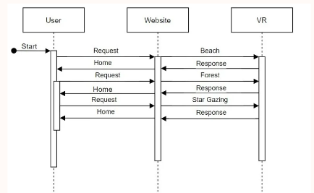
Figure 5.4 Sequence Diagram

5.5 Activity Diagram
An activity diagram for Mental Relaxation using Virtual Reality outlines the sequential steps and activities within a specific process or use case, such as "Environments". It details the actions taken by actors, decisions made, and interactions with system components. This diagram provides a clear, step-by-step visual representation of how a particular task or process is executed within the application.

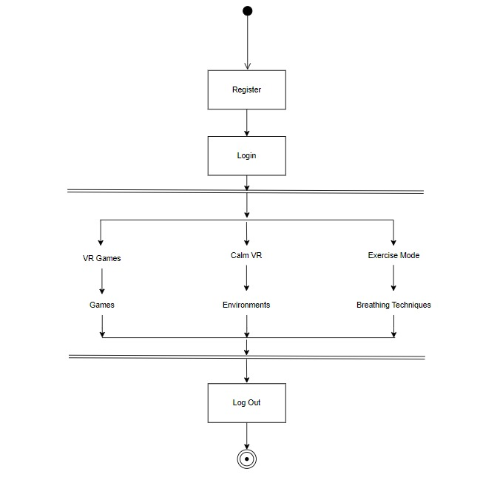
Figure 5.5 Activity Diagram

Implementation Details(Screenshots)
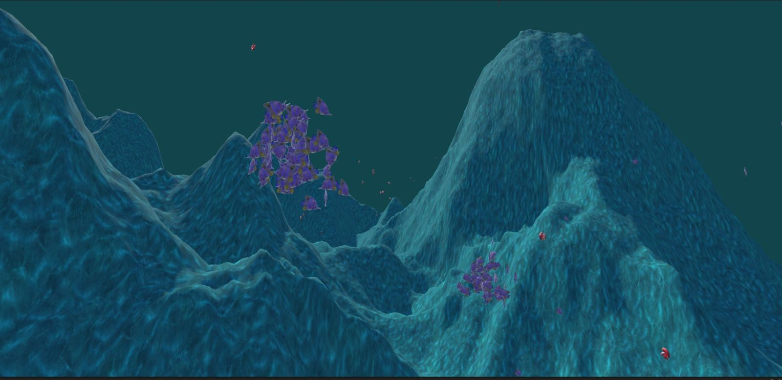
Figure 5.6.1 Underwater game environment
Imagine a strange, glowing world. Big, pointy mountains stick out of a dark, shiny sea. There are weird, plant-like things that light up, and tiny, moving lights everywhere. It looks like something from a dream.
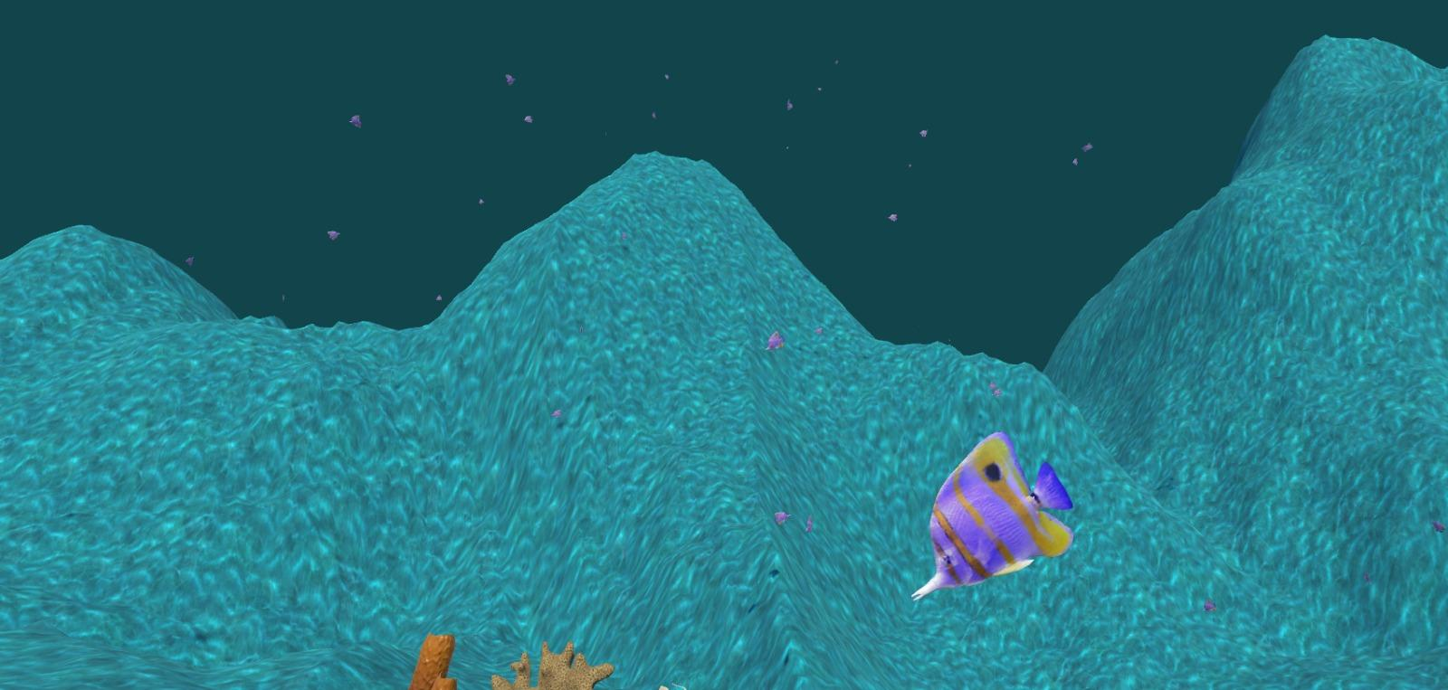
Figure 5.6.2 Underwater game environment
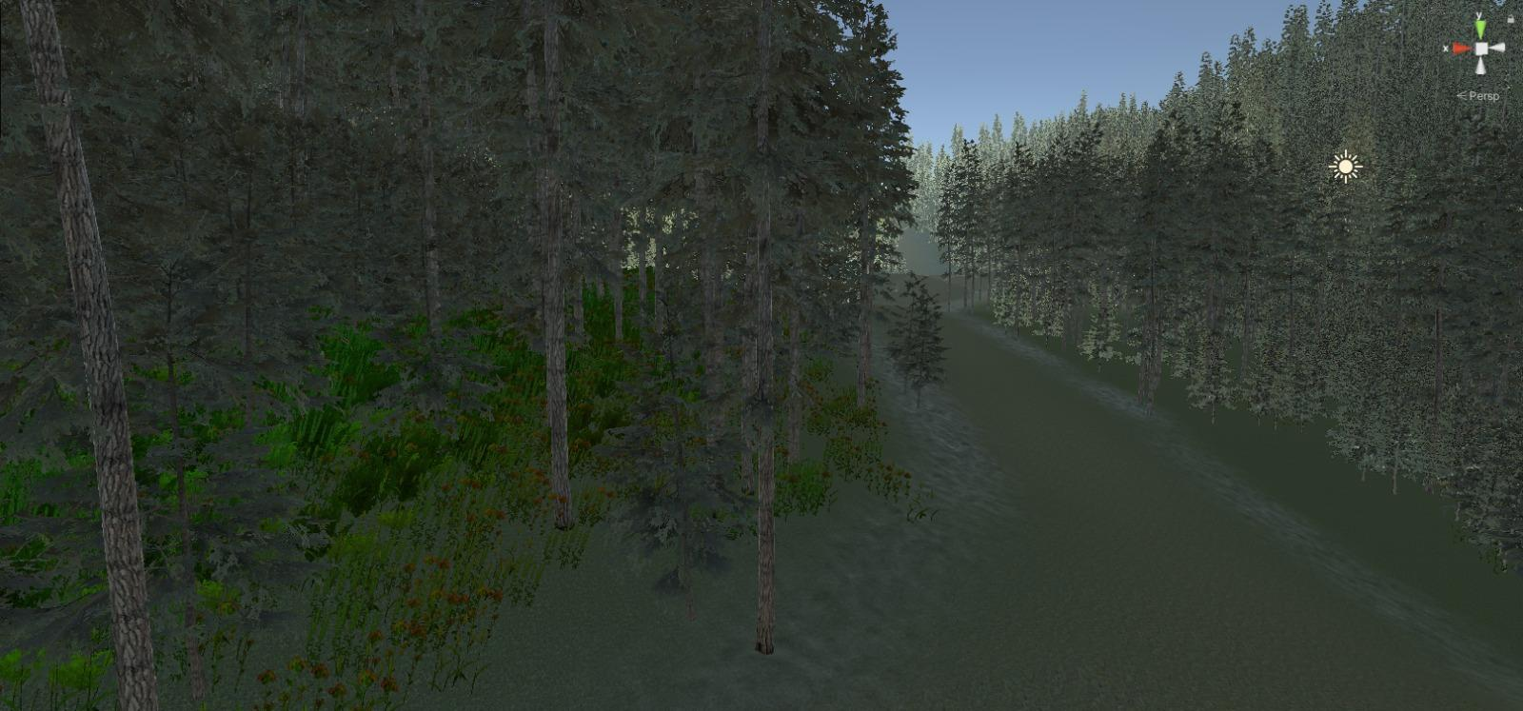
Figure 5.7.1 Forest Environment
Forest environment offers an immersive experience where users can explore lush, vibrant landscapes filled with towering trees and wildlife. With realistic sounds of nature and dynamic weather effects, it creates a serene and lifelike escape into the heart of the wilderness.
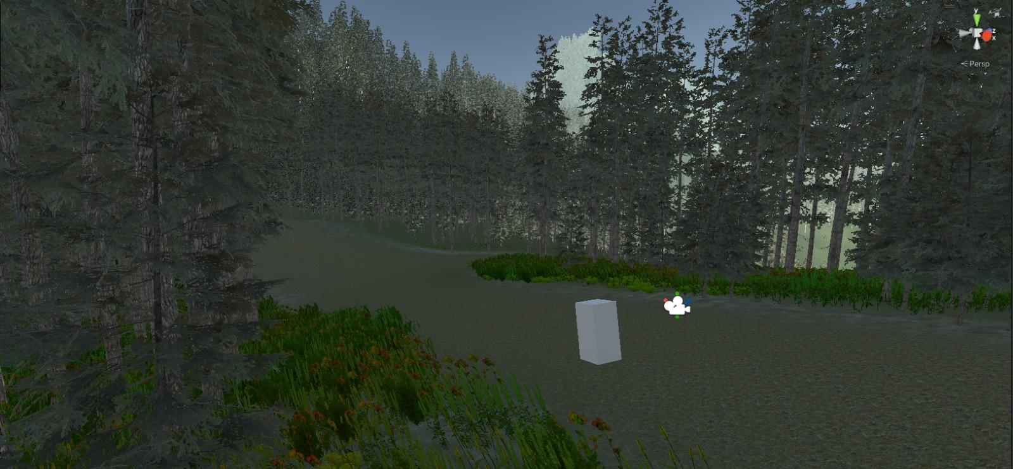
Figure 5.7.2 Forest Environment

Chapter 6
Experimental Setup
6.1 Technology Stack
6.1.1 Frontend:
For developing the android application to implement our problem definition efficiently and user- friendly, we have used the following technologies:
a. React:
A popular JavaScript library for building user interfaces, providing a component-based approach that makes it efficient to create and manage complex VR environments. React’s declarative syntax and virtual DOM facilitate smooth and interactive experiences. React’s component-based architecture promotes code reusability and maintainability, making it easier to manage large and complex VR projects. It also has a strong community and ecosystem, with a wide range of third- party libraries and tools available.
b. HTML & CSS:
Essential for structuring and styling the VR environment, including elements like menus, buttons, and informational overlays. HTML provides the basic structure of the VR environment, while CSS is used to style and position elements. HTML5 introduced new elements and attributes specifically for web-based VR and AR, such as <canvas> for rendering 3D graphics and <video> for displaying stereoscopic content. CSS3 offers various properties and techniques for creating immersive and visually appealing VR experiences, such as 3D transforms, animations, and transitions.
c. WebGL:
A JavaScript API that enables rendering 3D graphics in a web browser, providing the foundation for creating visually rich and immersive VR scenes. WebGL leverages the GPU to accelerate 3D rendering, resulting in smooth and high-performance VR experiences. WebGL supports various 3D graphics features, including lighting, shading, texturing, and effects. It also allows for interoperability with other web technologies, such as JavaScript and HTML5.
6.1.2 Backend:
In the backend part, we have used Express, NodeJS and MongoDB for the BeaconNext Application.
a. Flask:
A lightweight Python web framework that provides a simple and efficient way to handle server-side logic and API requests. Flask’s modular architecture and extensibility make it suitable for building scalable and maintainable VR applications. Flask’s minimalist approach allows developers to focus on building the core functionality of the VR application, without getting bogged down by complex boilerplate code. It also has a large and active community, with a wealth of resources and third-party extensions available.
b. MongoDB:
MongoDB is a popular NoSQL database technology known for its flexibility, scalability, and performance. It stores data in a flexible, JSON-like format, making it ideal for handling unstructured or semi-structured data. MongoDB’s distributed architecture allows for horizontal scaling across multiple servers, enabling seamless handling of large volumes of data. Its powerful query language and indexing capabilities facilitate efficient data retrieval and analysis. Additionally, MongoDB offers features such as high availability, automatic failover, and sharding for robust and reliable backend solutions.
6.1.3 VR Environment:
a. Unity:
A powerful game engine that provides a comprehensive set of tools for creating immersive VR experiences. It offers robust physics, graphics, and animation capabilities, making it well-suited for building complex and interactive virtual environments. Unity’s asset store provides a vast library of pre-built models, textures, and scripts, which can accelerate development and save time. It also supports various VR platforms, including Oculus Rift, HTC Vive, and PlayStation VR, making it a versatile choice for reaching a wide audience.
b. WebXR:
A web standard that enables VR and AR experiences directly in web browsers, making the
website accessible on a wider range of devices. It leverages modern web technologies like
WebGL and WebGPU for rendering graphics. WebXR offers a more accessible and platform-
agnostic approach to VR development, as it doesn’t require users to download and install any
additional software. It also allows for easier integration with other web-based services and
features.
6.2 Software and Hardware Setup
- Software Requirements: -
1. HTML
2. CSS
3. WebXR
4. Unity
5. Flask
6. MongoDB
7. React
8. WebGL
- Hardware Requirements:
1. VR Headset.
2. Controllers.
Chapter 7
Project Plan
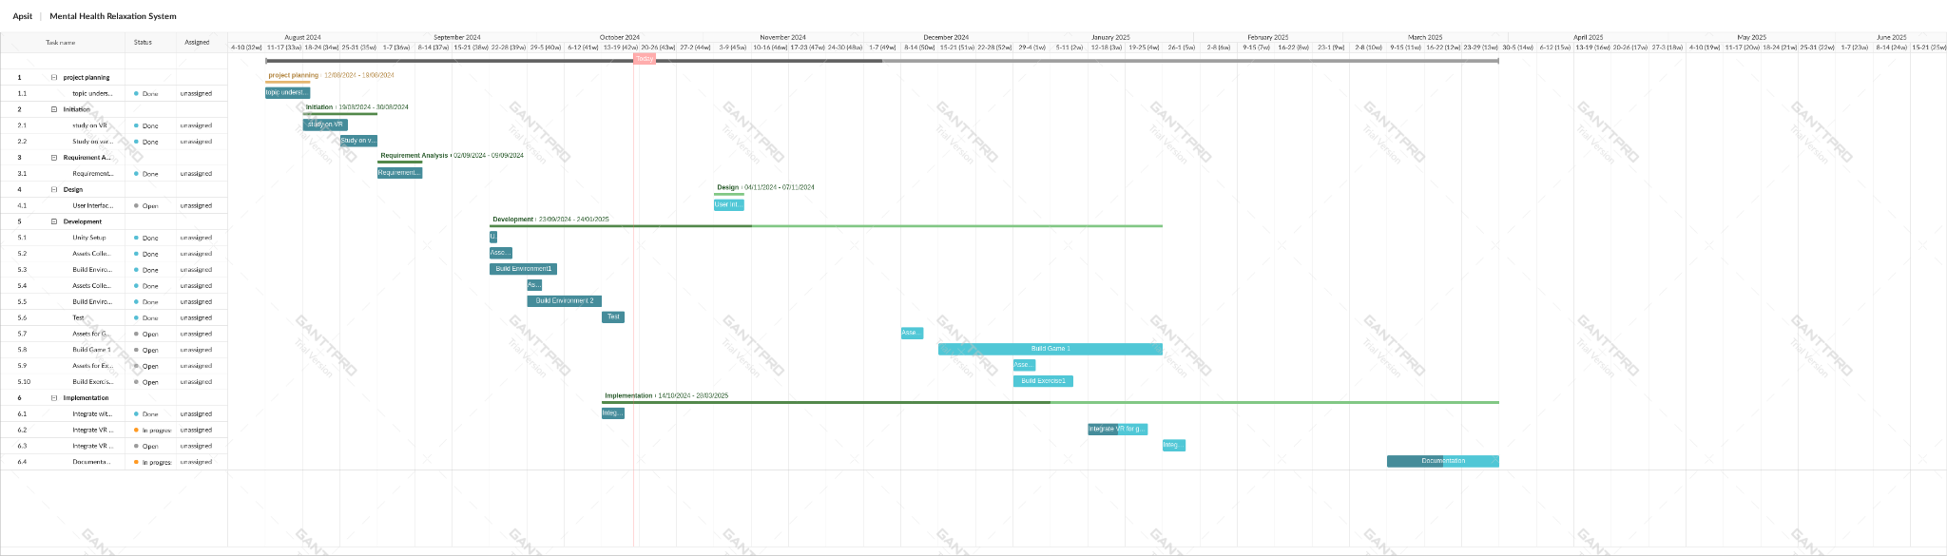
Figure 7.1 – Gantt Chart

Chapter 8
Expected Outcome
The expected outcomes of mental relaxation using VR technology are significant and hold great potential for enhancing well-being. Some key achievements that can be anticipated include:
- Immersive Relaxation Experience : VR technology creates highly immersive environments, allowing users to escape from real-world stressors. By simulating serene landscapes or calming virtual environments, users experience a sense of tranquility, aiding in mental relaxation more effectively than traditional methods.

- Real-Time Stress Reduction : With the use of VR for relaxation, individuals can experience immediate stress relief. VR allows real-time visualization of soothing environments, calming activities, or guided meditation, providing instant relaxation and reducing anxiety in the moment.

- Customization and Personalization : VR relaxation tools are highly adaptable and can be personalized to meet individual preferences. Users can choose specific environments, sounds, or even relaxation techniques tailored to their unique needs, enhancing the effectiveness of the experience.

- Enhanced Focus and Mindfulness : VR promotes deep focus by eliminating external distractions. This heightened level of concentration enhances mindfulness practices, allowing individuals to focus entirely on their mental relaxation, leading to more profound and lasting effects.

- Long-Term Mental Health Benefits : Repeated use of VR for relaxation can contribute to long-term mental health improvements. Consistent engagement with calming VR experiences can help reduce chronic stress, anxiety, and even symptoms of depression by creating a regular, effective relaxation routine.

- Accessibility and Convenience : VR relaxation methods can be accessed anytime and anywhere, making mental relaxation more convenient. This flexibility is particularly beneficial for people with busy lifestyles, providing a practical way to incorporate stress relief into their daily routines without the need for travel or additional resources.
In conclusion, the use of VR for mental relaxation is expected to deliver significant benefits by creating immersive, personalized relaxation experiences. By promoting real-time stress reduction, enhancing focus, offering long-term mental health benefits, and ensuring accessibility, VR technology has the potential to revolutionize how individuals achieve and maintain mental well-being.

References
[1] Hamdani SU, Zill-E-Huma, Zafar SW, Suleman N, Um-Ul-Baneen, Waqas A, Rahman A, “Effectiveness of relaxation techniques to reduce distress, anxiety and depression in adolescents”, Human Development Research Foundation (HDRF), Pakistan, Institute of Population Health, Department of Primary Care and Mental Health, University of Liverpool, UK. (September 30, 2020), DOI:10.13140/RG.2.2.21982.36168

[2] Rita Cola Carroll “Guided imagery: Harnessing the power of imagination to combat workplace stress for health care professionals”,Drexel University, USA, Journal of Interprofessional Education & Practice Volume 28, September 2022, 100518, Received 8 March 2022, Accepted 13 April 2022, Available online 25 April 2022, Version of Record 20 June 2022.

[3] Toussaint L, Nguyen QA, Roettger C, Dixon K, Offenbächer M, Kohls N, Hirsch J, Sirois F. “Effectiveness of Progressive Muscle Relaxation, Deep Breathing, and Guided Imagery in Promoting Psychological and Physiological States of Relaxation”, Evid Based Complement Alternat Med. 2021: 5924040 | Published online 2021 Jul 2. doi: 10.1155/2021/5924040

[4] Daniela Villani, Francesco Riva, Giuseppe Riva “New Technologies for Relaxation: The Role of Presence”, Article in International Journal of Stress Management | August 2007, DOI: 10.1037/1072-5245.14.3.260

[5] Ioannis Ladakis, Filos D, Chouvarda Ioanna “Virtual reality environ- ments for stress reduction and management: a scoping review”, https://doi.org/10.1007/s10055-024-00943-y , Received: 10 October 2022 / Accepted: 30 January 2024 / Published online: 27 February 2024.

[6] Rishikeshava Damarla “Virtual Reality and Mental Health Care”, Volume 11 Issue 4 (2022), 1 Washington High School.

[7] Shakila Meshkat , Mahsa Edalatkhah , Corinna Di Luciano , Josh Martin , Gursharanjit Kaur , Gyu Hee Lee , Haley Park , Andrei Torres , Ali Mazalek , Bill Kapralos , Adam Dubrowski , Venkat Bhat “Virtual Reality and Stress Management: A Systematic Review”, Cureus. 2024 Jul; 16(7): e64573. Published online 2024 Jul 15. doi: 10.7759/cureus.64573

[8] Colombo Desirèe, Díaz-García Amanda, Fernández-Álvarez Javier, Botella Cristina “Virtual Reality for the Enhancement of Emotion Regulation”, Article in Clinical Psychology & Psychotherapy May 2021 | DOI: 10.1002/cpp.2618

[9] Bell IH, Nicholas J, Alvarez-Jimenez M, Thompson A, Valmaggia L. “Virtual reality as a clinical tool in mental health research and practice”, Dialogues Clin Neurosci. 2020 Jun; 22(2): 169–177. DOI: 10.31887/DCNS.2020.22.2/lvalmaggia

[10] Joana Pinheiro, Raquel Simões de Almeida, António Marques “Emotional self-regulation, virtual reality and neurofeedback”, Center for Rehabilitation Research - Psychosocial Rehabilitation Lab, School of Health of P.PORTO, Porto, Portugal (2021)

[11] Freeman D, Reeve S, Robinson A, Ehlers A, Clark D, Spanlang B, Slater M. “Virtual reality in the assessment, understanding, and treatment of mental health disorders.”, Psychol Med. 2017 Oct; 47(14): 2393–2400. Published online 2017 Mar 22. doi: 10.1017/S003329171700040X

[12] Grace Williams , Mariam Riaz , Eugenia Drini , Simon Riches “Virtual reality relaxation for mental health staff in complex care services: A feasibility and acceptability study”, Mental Health & Prevention Volume 33, March 2024, 200318
https://doi.org/10.1016/j.mhp.2023.200318

[13] Grace Williams, Eugenia Drini, Simon Riches “Virtual Reality Relaxation for Mental Health Service Users with Complex Care Needs: a Pilot Study in Residential Care Homes and Supported Accommodation”, Journal of Psychosocial Rehabilitation and Mental Health
2024-04-12 | Journal article. DOI: 10.1007/s40737-024-00399-y

